 | 12.1.12 Editors - Geometry Nodes Editor - Header - Add Menu - Input
Table of content
Detailed table of content 1
Add menu - Input 3
Collection Info 4
Boolean 4
Color 5
Image Input 5
Integer 6
Is Viewport 7
Material 7
Object Info 7
Self Object 8
String 8
Value 8
Vector 8
ID 9
Index 9
Named Attribute 9
Normal 10
Position 10
Radius 11
Scene time 11

Detailed table of content
Detailed table of content
Detailed table of content 1
Add menu - Input 3
Collection Info 4
Inputs 4
Collection 4
Properties 4
Transform Space 4
Original 4
Relative 4
Outputs 4
Geometry 4
Boolean 4
Properties 4
Value 4
Outputs 4
Boolean 4
Color 5
Outputs 5
Color 5
Image Input 5
Input 5
Image 5
New 5
Open 5
Image prop 5
Image browser 5
Image name 5
Fake user 5
New 6
Open Image 6
Remove 6
Frame 6
Outputs 6
Width 6
Height 6
Has Alpha 6
Frame Count 6
FPS 6
Integer 6
Properties 6
Value 6
Outputs 6
Integer 6
Is Viewport 7
Outputs 7
Is Viewport 7
Material 7
Outputs 7
Material 7
Object Info 7
Inputs 7
Object 7
Outputs 7
Location 7
Rotation 7
Scale 7
Geometry 7
Self Object 8
String 8
Properties 8
String 8
Outputs 8
Value 8
Value 8
Properties 8
Value 8
Outputs 8
Value 8
Vector 8
X Y Z 8
Output 9
Vector 9
ID 9
Outputs 9
ID 9
Index 9
Outputs 9
Index 9
Named Attribute 9
Input 9
Name 9
Input 9
Data Type 9
Output 10
Attribute 10
Normal 10
Face 10
Mesh Vertices 10
Edge 10
Face Corner 10
Curve Control Points 10
Warning! 10
Outputs 10
Normal 10
Position 10
Outputs 11
Position 11
Radius 11
Outputs 11
Radius 11
Scene time 11
Outputs 11
Seconds 11
Frame 11

Add menu - Input
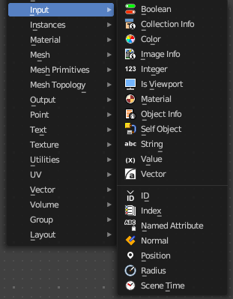
Here you find input nodes.

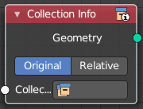
Collection Info
The Collection Info node retreives information from collections. This can be useful to use an external collection to control parameters in the geometry node tree.

Inputs

Collection
Collection to get the properties from.

Properties

Transform Space
The transformation of the geometry outputs.

Original
Output the geometry relative to the collection offset.

Relative
Bring the input collection geometry into the modified object, maintaining the relative position between the objects in the scene.

Outputs

Geometry
Geometry of the collection in world space with all its modifiers applied.

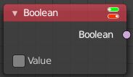
Boolean
Inputs a boolean value.

Properties

Value
The input boolean.

Outputs

Boolean
The boolean state.

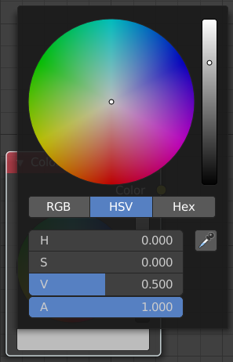
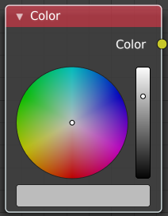
Color
Define a input color.
This node is a color wheel.
Clicking at the color field at the bottom will reveal the standard Blender color dialog, where you can input numeric values.

Outputs

Color
Standard color output.

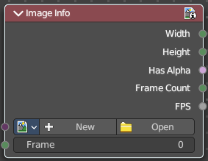
Image Input
Retreive infos from an image.

Input

Image
Load or connect a image.

New
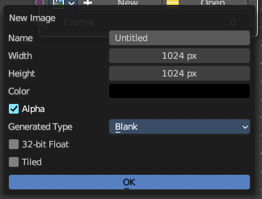
Create a new image.
Opens a new image dialog where you can adjust the color, size and further settings.

Open
Open a existing image.

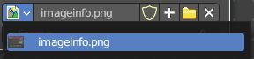
Image prop

Image browser
A list of available images

Image name
The name of the image

Fake user
Add a fake user to this asset.

New
Create a new image.
Opens a new image dialog where you can adjust the color, size and further settings.

Open Image
Open a existing image.

Remove
Removes the image as the active image.

Frame
For videos. Which frame to use.

Outputs

Width
The width of the image.

Height
The height of the image

Has Alpha
Returns true if the image has an alpha channel

Frame Count
For movies. How many frames.

FPS
For movies, what FPS rate.

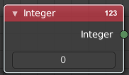
Integer
Inputs a integer value.

Properties

Value
The input integer.

Outputs

Integer
The integer value.

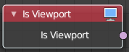
Is Viewport
The Is Viewport node outputs true when geometry nodes is evaluated for the viewport. For the final render the node outputs false.

Outputs

Is Viewport
A booleran that indicates if the geometry nodes is evaluated for preview.

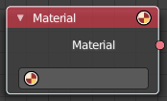
Material
Retreive a material.

Outputs

Material
The material output.

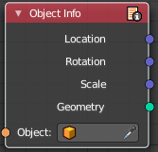
Object Info
The Object Info node retreives information from objects. And outputs it then.

Inputs

Object
Object to get the properties from.

Outputs

Location
Location of the object in world space.

Rotation
Rotation of the object in world space.

Scale
Scale of the object in world space.

Geometry
Geometry of the object in world space with all its modifiers applied.

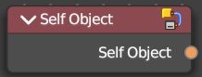
Self Object
Retreives the parent object of the geometry nodes.

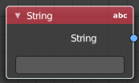
String
Input a string.

Properties

String
The string that you want to input.

Outputs

Value
The value set in the node properties.

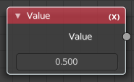
Value
Input numerical values to other nodes in the tree.

Properties

Value
Single numerical value (floating point).

Outputs

Value
The value set in the node properties.

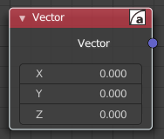
Vector
Creates a single vector of three values that can be used as an input.
Properties

X Y Z
The values of the vector.

Output

Vector
Standard vector output.

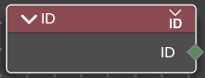
ID
Retreive the ID of the object.

Outputs

ID
The ID of the object.

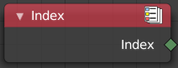
Index
Retreives an integer value indicating the position of each element in the list. This list depends on the internal order of the data in the geometry, which is not necessarily visible in the 3D Viewport. However, the index value is visible in the left-most column in the Spreadsheet Editor.

Outputs

Index
Integer value which enumerates each point on the geometry.

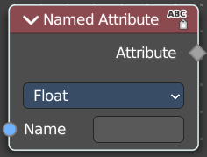
Named Attribute
Adds a field input.

Input

Name
The input name for the field.

Input

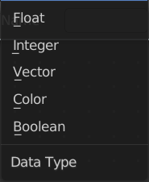
Data Type
What data type to use.

Output

Attribute
The output attribute name.

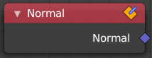
Normal
Returns a vector for each evaluated point indicating the normal direction. The output can depend on the attribute domain used in the node evaluating the field, but the output is always a normalized unit vector.
The output depends on where you plug in the normal node.

Face
On the face domain, the normal is the “up” direction of the face.

Mesh Vertices
For mesh vertices, the normal is an average of the surrounding face normals. If the vertex does not have any connected faces, the output is simply the normalized position of that vertex.

Edge
The normal output for each edge is the average of the edge’s two vertex normals.

Face Corner
The output for each face corner is the same as the face normal of the corresponding face.

Curve Control Points
The output of this node when used for curve geometry is the evaluated normal of the curve, which depends on the twist method. The normal vector is always perpendicular to the direction of the curve’s path at every point.

Warning!
Please keep in mind that for NURBS and Bézier spline curves the value retrieved from this node is the value at every control point. Which may not correspond to the visible evaluated points. For NURBS splines the difference may be even more pronounced and the result may not be as expected. A Resample Curve Node can be used to create a poly spline, where there is a control point for every evaluated point.

Outputs

Normal
The normal vector output.

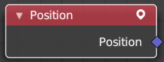
Position
The Position node outputs a vector of each point of the geometry the node is connected to.
The node can work on geometry domains besides points. In that case, the position data will be automatically interpolated to the new domain. For example, when used as part of the input to the mesh edge split node, the position for each edge will be the average position of the edges two vertices.
For instances, the output is the origin of each instance. However, if the node is for a geometry node that adjusts data inside instances, the position output of this node will be in the local space of each instance.

Outputs

Position
The position vector output.

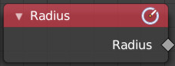
Radius
Retreive the radius of the object.

Outputs

Radius
The radius output.

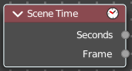
Scene time
Outputs the current scene time in seconds or in frames.
The Frame output is a float value to make subframe rendering for motion
blur possible.

Outputs

Seconds
Output in seconds.

Frame
Output in Frames.

